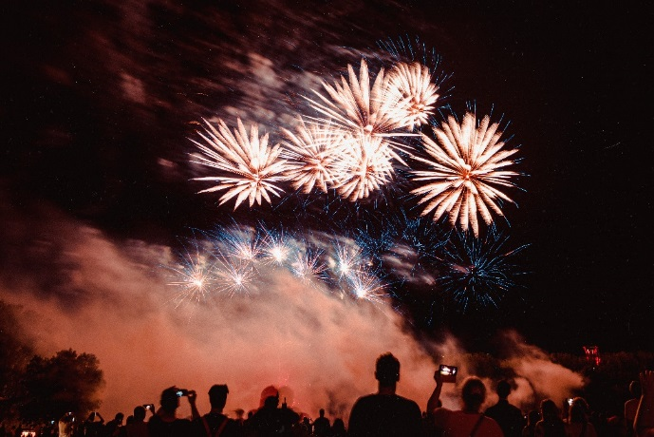

***Susquehanna Valley Country Club***

***Fireworks 2024***

*The annual SVCC Independence Day fireworks are an integral part of our club’s history and spirit. This well-attended event offers an opportunity for members, guests, neighbors, and friends to celebrate and enjoy a family oriented evening together watching the fireworks show overlooking the beautiful Susquehanna River Valley.* ***This year the Fireworks Show will be take place on Saturday, July6th, after 9pm.***

*Due to the high cost of the fireworks production, the SVCC must rely on generous donations from members, guests and local businesses to continue with the high quality show that we are accustomed to having. The fireworks show is at the best location in the valley. If you believe in the significance of this patriotic event at the SVCC, please consider donating to help your club and promote our celebration of our Nation’s Independence Day!*

*The cost of the fireworks is not part of the SVCC annual operational budget and we are requesting donations to continue a tradition here in the Valley. A contributor form is provided below for your generous donations. The club strongly encourages all donors to make a check or cash donation. Thank you for your support!*

*---------------------------------------------------------------------------------------------------*

*SVCC 2024 Fireworks Donation Request*

*Member Name ______________________________________________*

*Member Number _______________*

*Contribution: $25 __ $50 __ $100 __ Other $ _______________*